SERMON – ‘Looking forward to the City-What will heaven be like? Heb 11:10, Rev 21 - 22:5

Hope in the reality of heaven is looking towards something in the future in a way that POSITIVELY, POWERFULLY & PERSONALLY affects our living NOW.
A compelling vision heaven
affects our lives with a
a convincing hope of all things made new.

5 Observations about the reality of heaven:

#1 New heaven and new earth will be ____________ .
v1,2,5

#2 New heaven and new earth will be ___________ .

#3 New heaven and new earth will predominantly be a _______________ .
v2, 9

HEB 13:14 Therefore let us go to him outside the camp and bear the reproach he endured. For here we have no lasting city, but we seek the city that is to come.

#4 New heaven and new earth will be ________________.

#5 New heaven and new earth will be saturated with the ____________ _____ _____________ .
v10-11 , v23; 22:4-5

Answers: New, Real, City, Beautiful, Glory of God

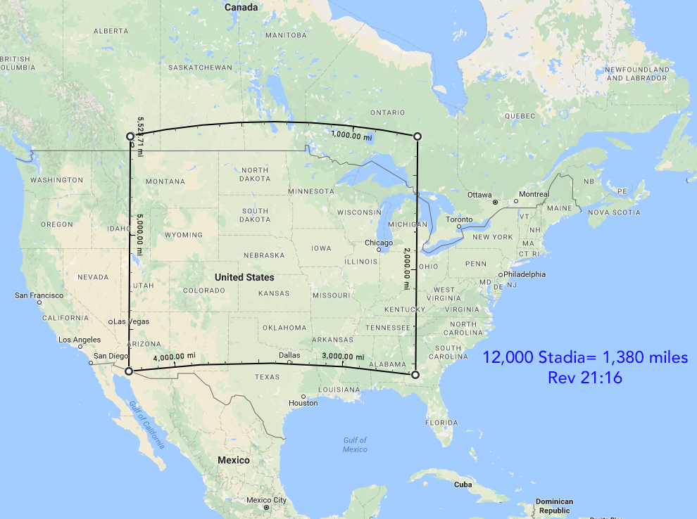
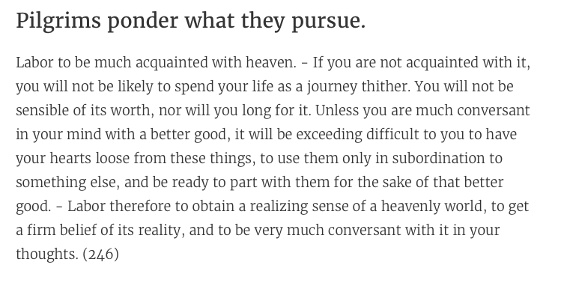

Discussion / Application

- Describe in detail a favorite place you like to visit.

- How does this passage help you describe the reality of heaven?

- Why is it hard for us to grasp the reality of heaven?

- How is the presence of God the most comforting characteristic of heaven? In what specific way?

- Abraham (Heb 11:10) “was looking forward to the city” with hope. How is that an example for us?

